***MySQL Assignment***

***Student Name: Syeda Attira Hashmi***

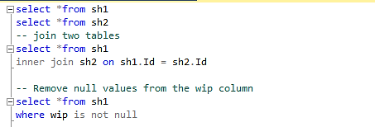

# Q1) Which Department has the highest overtime?

## Query:

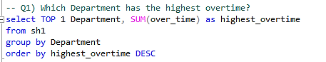

## Result



# Q2) Insert a new row with random values into the table "Employee_dataset".

## Query



## Result

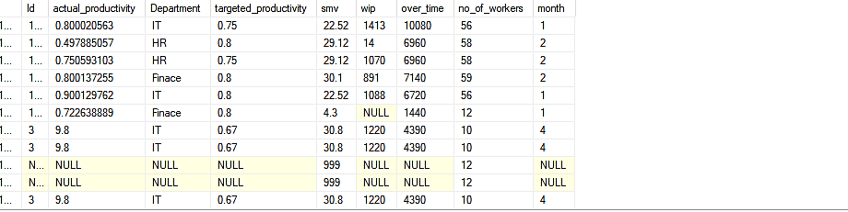

# Q3) Order by Highest to lowest Overtime by Department?

## Query

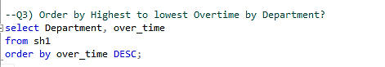

## Result

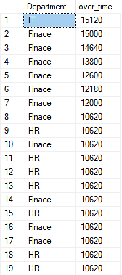

# Q4 ) Which Department had the most work?

## Query

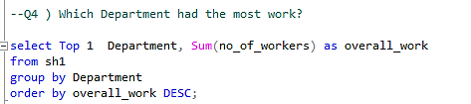

## Result



# Q5) Which two departments have the highest productivity?

## Query

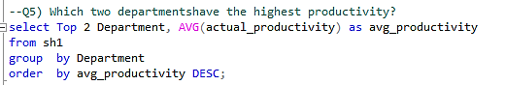

## Result

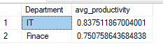

# Q6) Whats the total wip by Month?

## Query

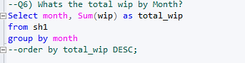

Result

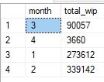

# Q7) Insert a new row into the table "Employee_dataset" with columns "smv" and "noofworkers"?

## Query

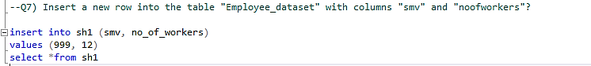

## Result



# ESSAY

# Q8) What do you think are the pros and cons of the dataset "Employee_dataset"to be used in actual business settings?

The employee_dataset is an excellent asset for garment manufacturing companies. It contains a lot of data on worker efficiency, hours of overtime worked, and work quantity. This data may be utilised to discover areas where productivity can be increased, to better manage assets, and to make more informed choices about workforce numbers.

Pros when employing the employee_dataset in real-world business settings:

The dataset is broad and detailed, including a wide range of characteristics that can influence productivity among workers. Industry specialists evaluate and analyse the data, guaranteeing its accuracy and reliability. The dataset is simple to use and accessible via a wide range of platforms. Because the dataset is freely to be utilised, it provides a low-cost option to boost staff productivity.

The following are the cons when employing the employee_dataset in real-world business settings:

Because the dataset is tailored to the garment manufacturing business, it may not be applicable to other sectors. Because the dataset cannot be modified in real time, it might fail to capture the most recent employee productivity patterns. Because the dataset is missing details regarding individuals’ employees, it cannot be utilised to track the way they perform.

Overall, the employee_dataset is a valuable resource for garment manufacturers. It provides a wealth of knowledge that may be utilised to increase worker efficiency and make better hiring decisions. However, the information provided is restricted to the garment manufacturing industry and cannot be modified in real time.

In conclusion, the "Employee_dataset" has useful attributes for analysing garment production procedures and determining the efficiency of workers. It aids decision-making by providing information about departmental efficiency, work distribution, and productivity patterns. The dataset can be used to evaluate performance, optimise processes, and analyse historical trends. However, drawbacks include the study's exclusive emphasis on garment production, a lack of contextual knowledge, potential data quality difficulties, limited applicability to other businesses, and ethical concerns. Despite these restrictions, when interpreted correctly and utilised within its intended scope, the dataset can be an invaluable asset. In genuine corporate situations, careful examination, contextualization, and commitment to ethical principles are required for obtaining helpful information and making educated judgements.